
Department of Computer And Science and Engineering
CS23334 Fundamentals of Data Science Lab III semester II-Year (2023R)
Name of the Student: Elamvazhuthi.MS
Register Number:2116240701133

Exp No:1. a Analyze the trend of data science job postings over the last decade
Description: Use web scraping (e.g., BeautifulSoup) or APIs (e.g., LinkedIn API) to gather data on the number of data science job postings each year. Use pandas for data manipulation and matplotlib/seaborn for visualization.
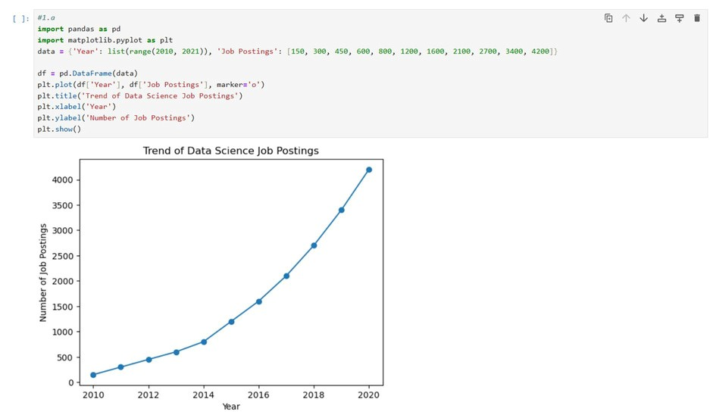
Exp No:1. b Analyze and visualize the distribution of various data science roles (Data Analyst, Data Engineer, Data Scientist, etc.) from a dataset.
Description: Use a dataset of job postings and categorize them into different roles. Visualize the distribution using pie charts or bar plots.
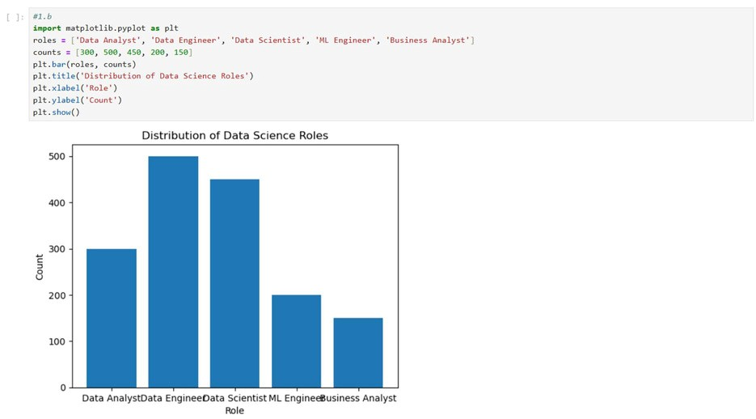
Exp No:1. c Conduct an Experiment to differentiate Structured, Un-structured and Semistructured data based on data sets given.
Description: Create small datasets for each type and Explain their characteristics.
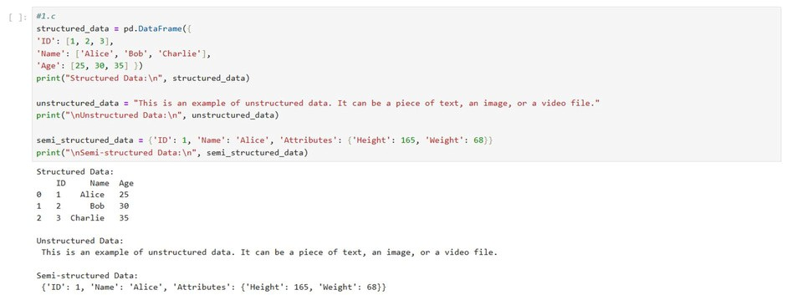
Exp No:1. dConduct an Experiment to encrypt and decrypt given sensitive data.
Description: Use the cryptography library to encrypt and decrypt a piece of data.
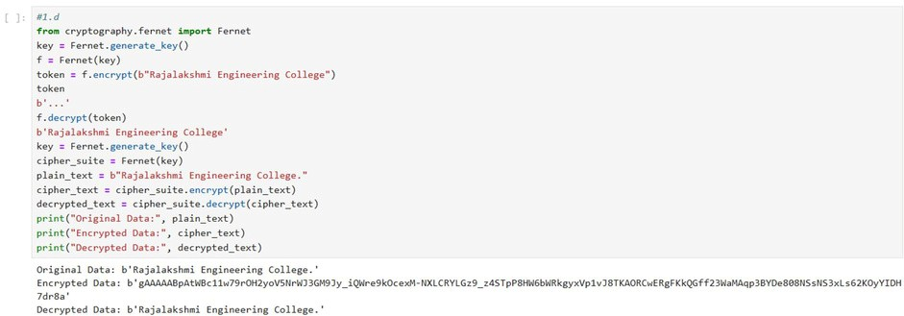
Exp No:2 Upload and Analyze the data set given in csv format and perform data preprocessing and visualization.
Description: Use sample data set sales-data. csv.
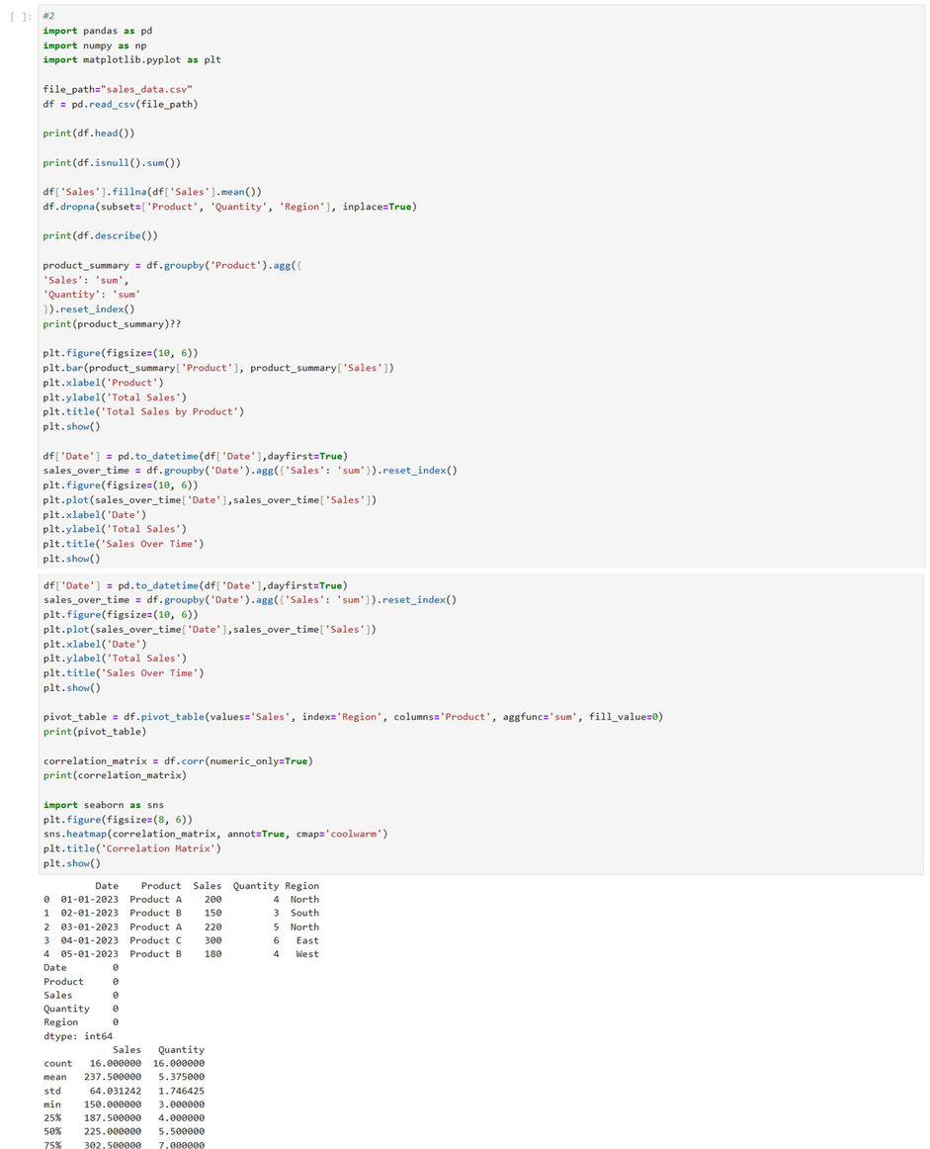

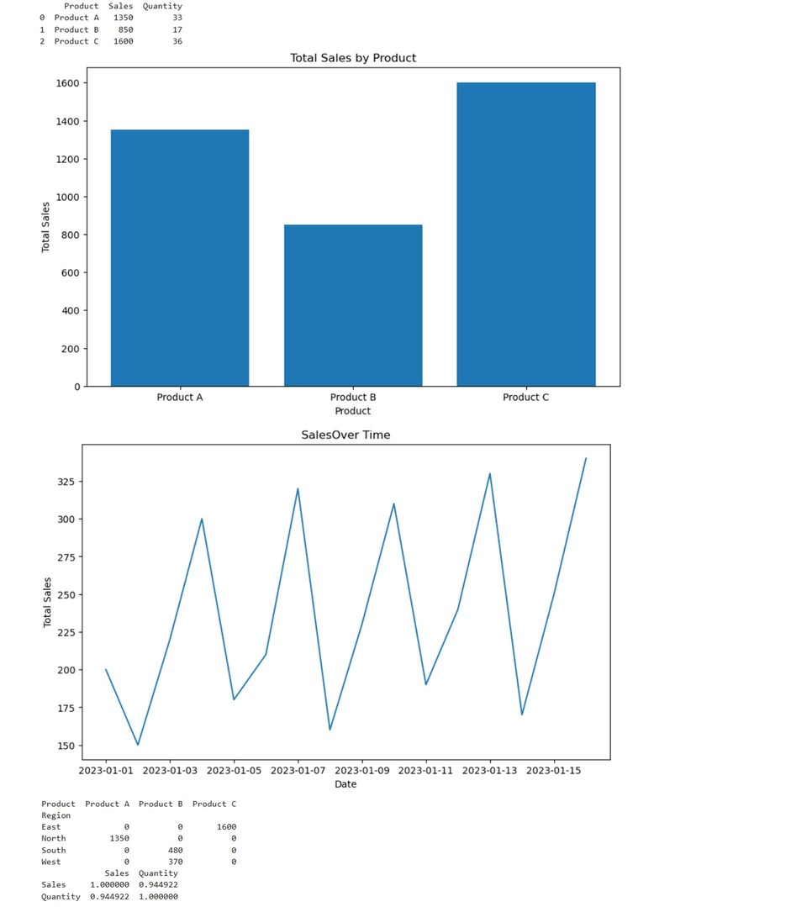
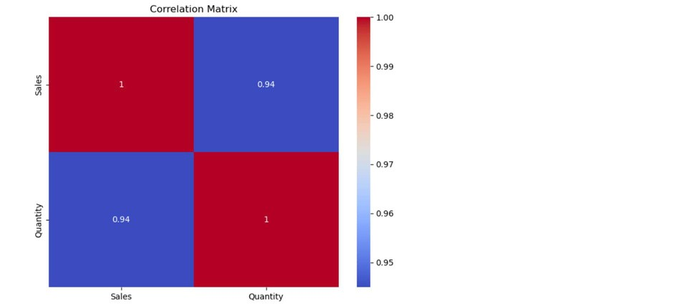

Exp No:3. aConduct an Experiment to show data visualization using line plot
Description: Take any sample data either through csv file or data fetched directly through code.
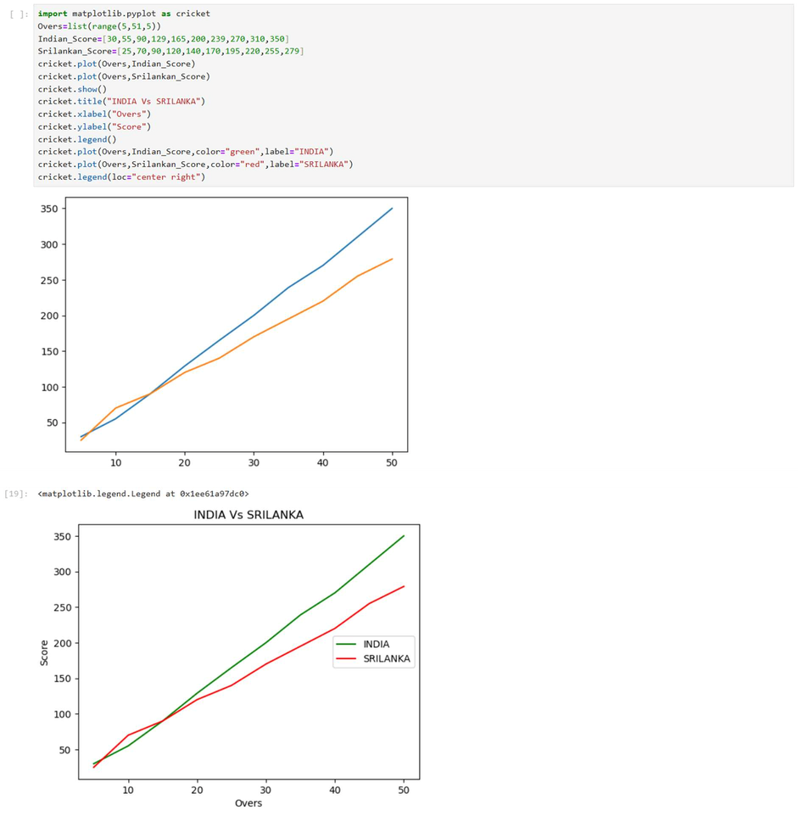
Exp No:3. bConduct an Experiment to show data visualization using bar chart.
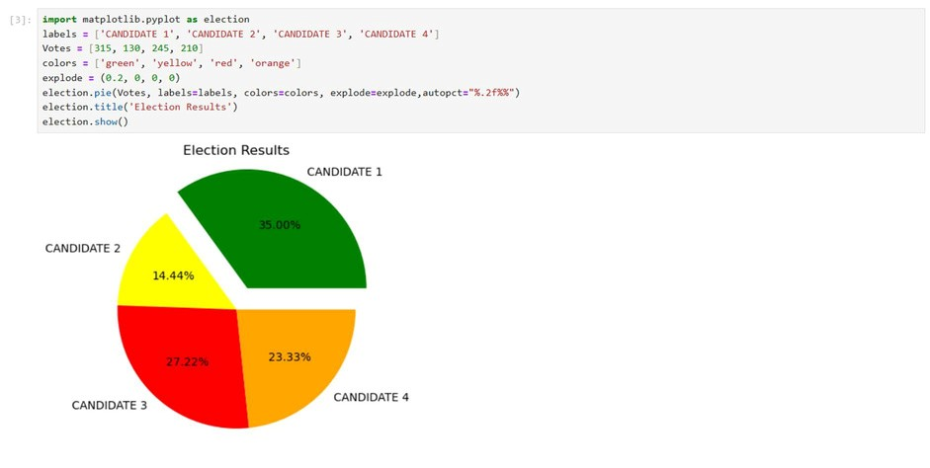
Description: Take any sample data either through csv file or data fetched directly through code.
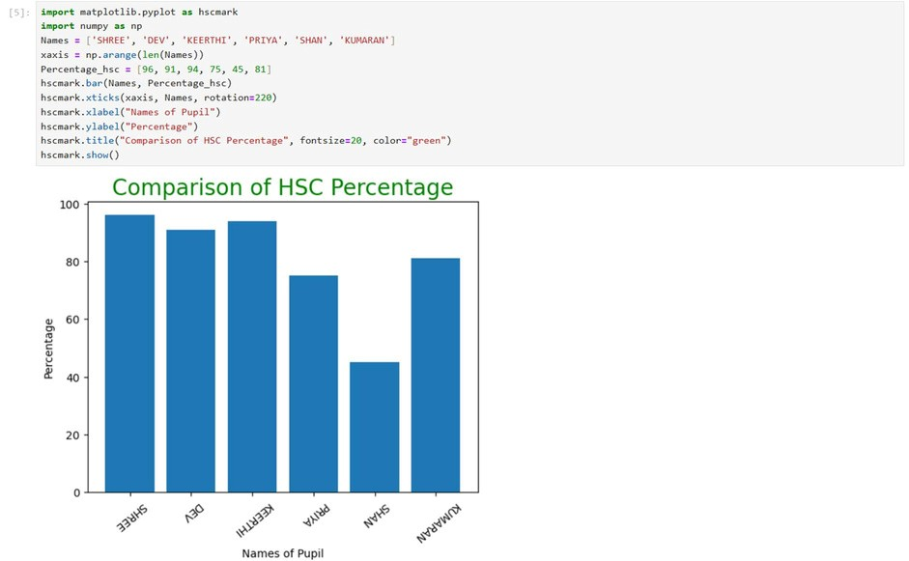
Exp No:3. cConduct an Experiment to show data visualization using pie chart.
Description: Take any sample data either through csv file or data fetched directly through code.
Exp No:4 To Count the frequency of occurrence of a word in a body of text is often needed during text processing.
Description: Import the word_tokenize function and gutenberg.
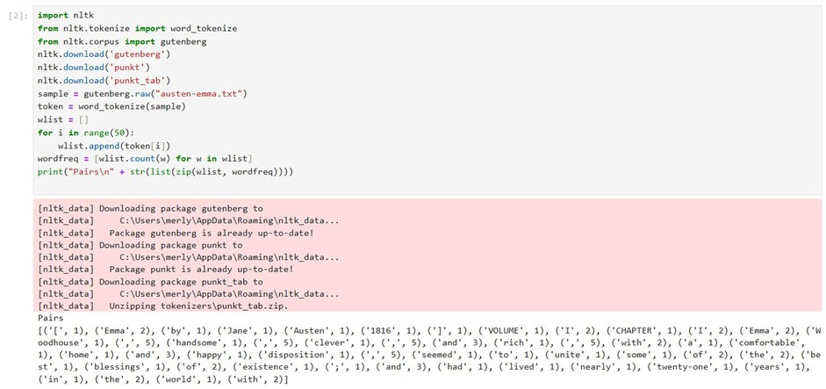
Exp No:5Data Collection and Initial Exploration
Objective: To collect, load, and perform initial Exploration of the diabetes dataset.
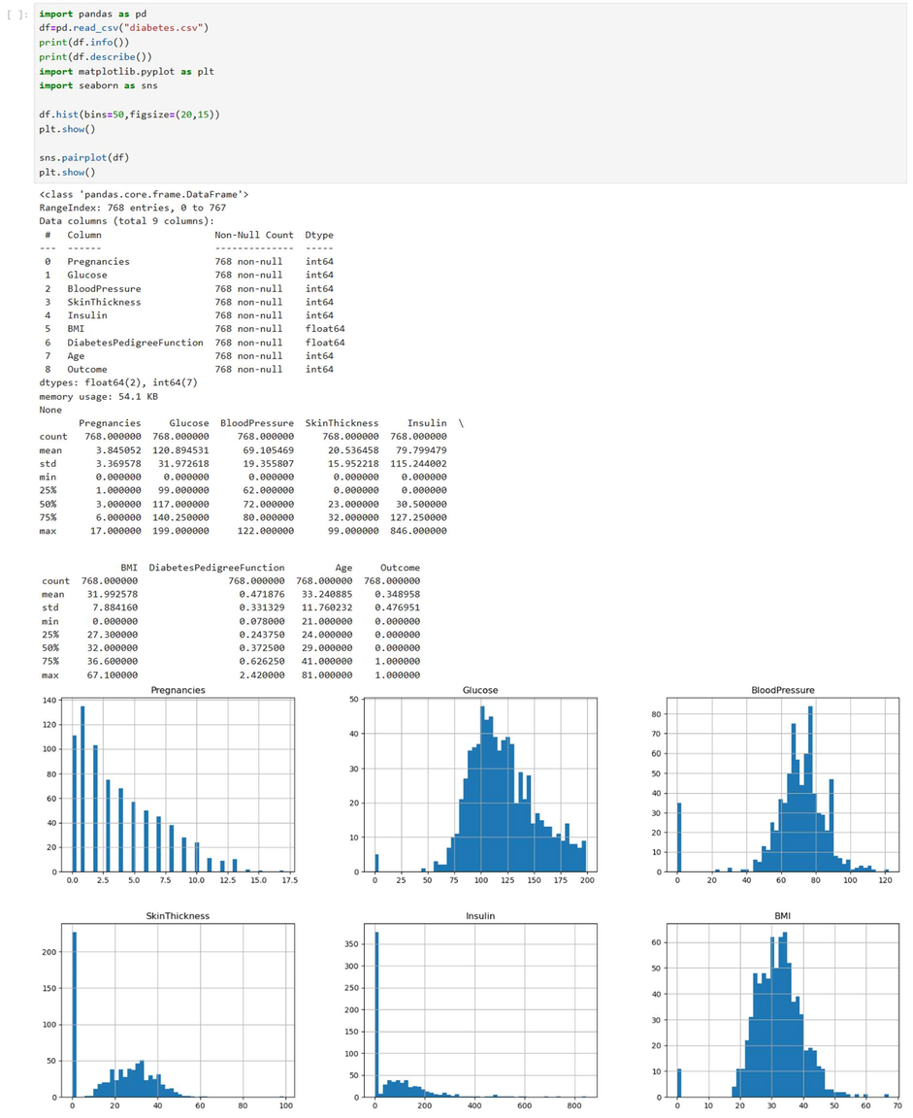

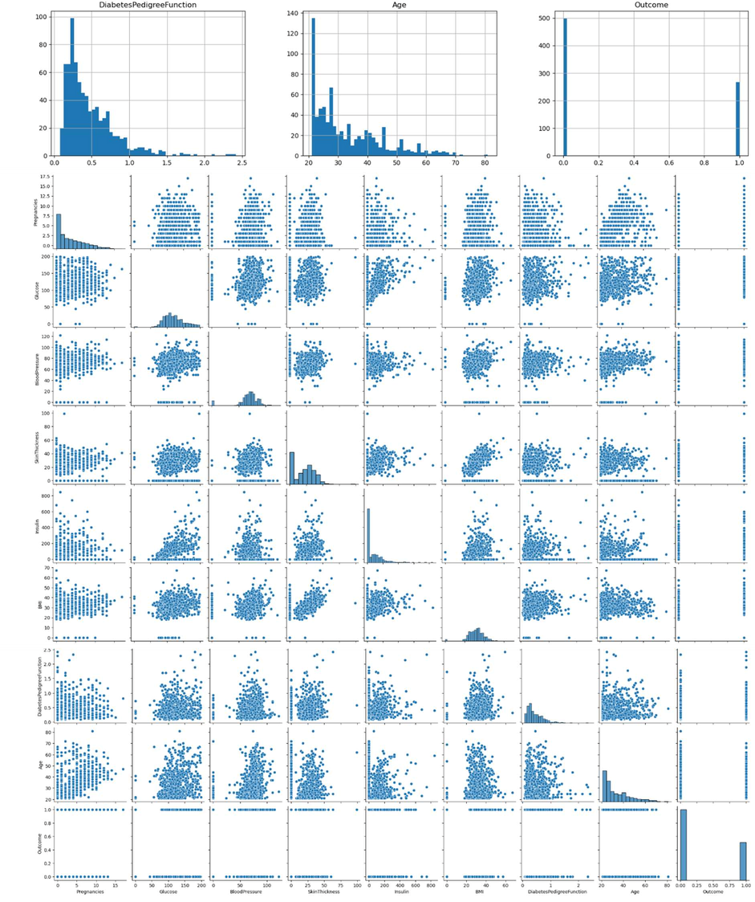

Exp:6 Handling Missing and Inappropriate Data in a Dataset
Aim: Demonstrate an Experiment to handle missing data and inappropriate data in a Data set using Python Pandas Library for Data Preprocessing.
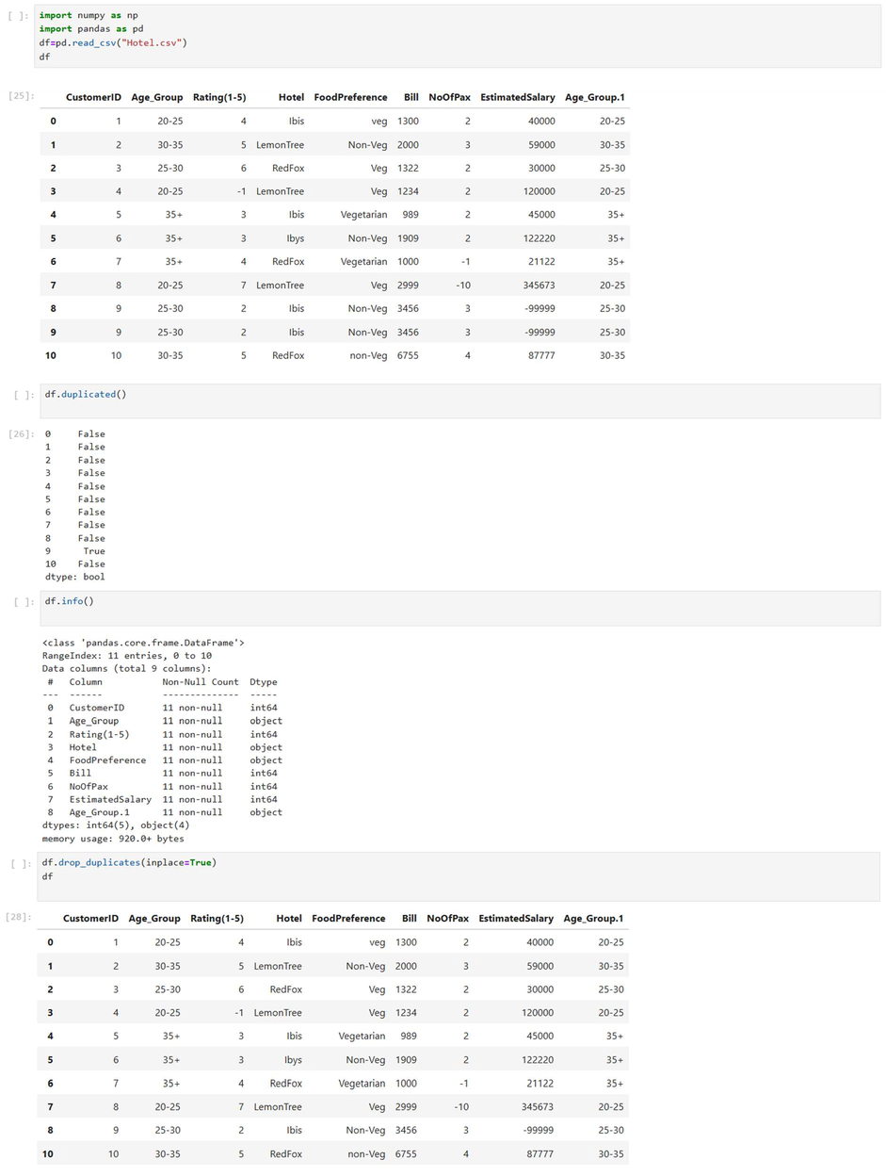

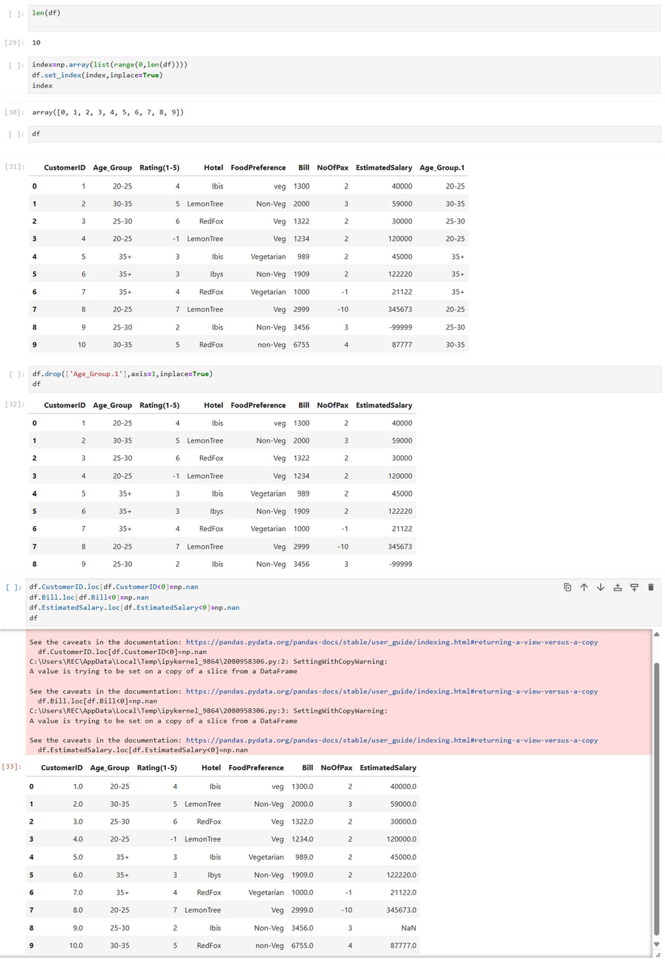
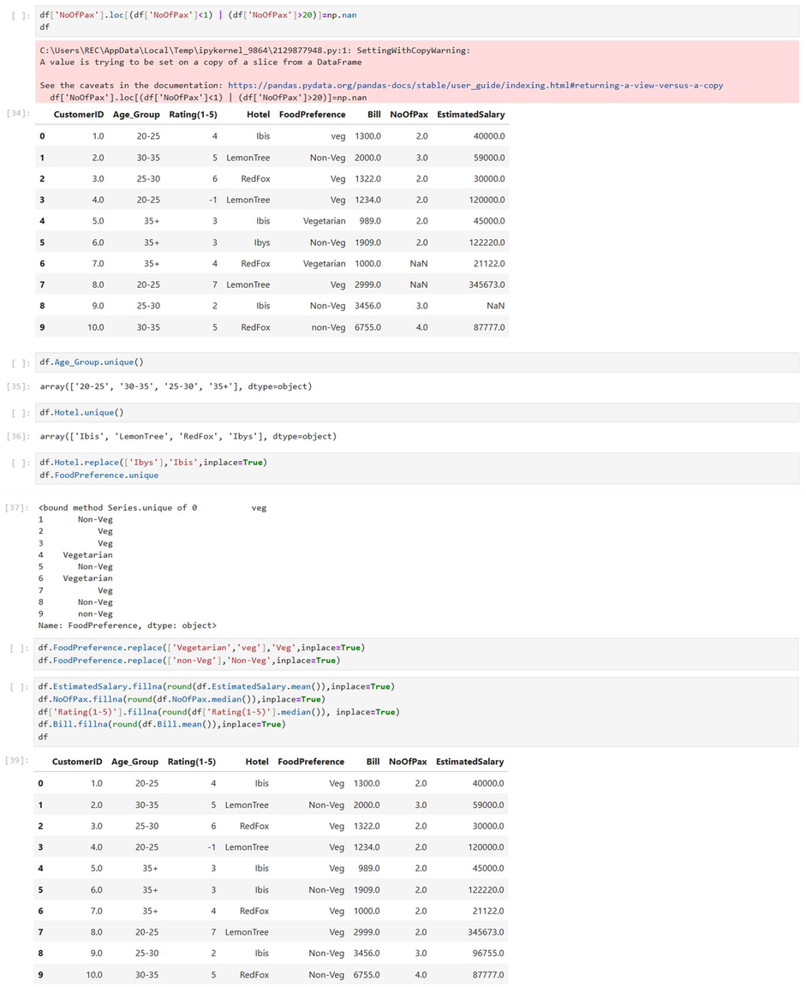

Exp:7 Experiment to detect outliers in a given data set.
Description: Understand the procedure to identify the outliers in a given dataset
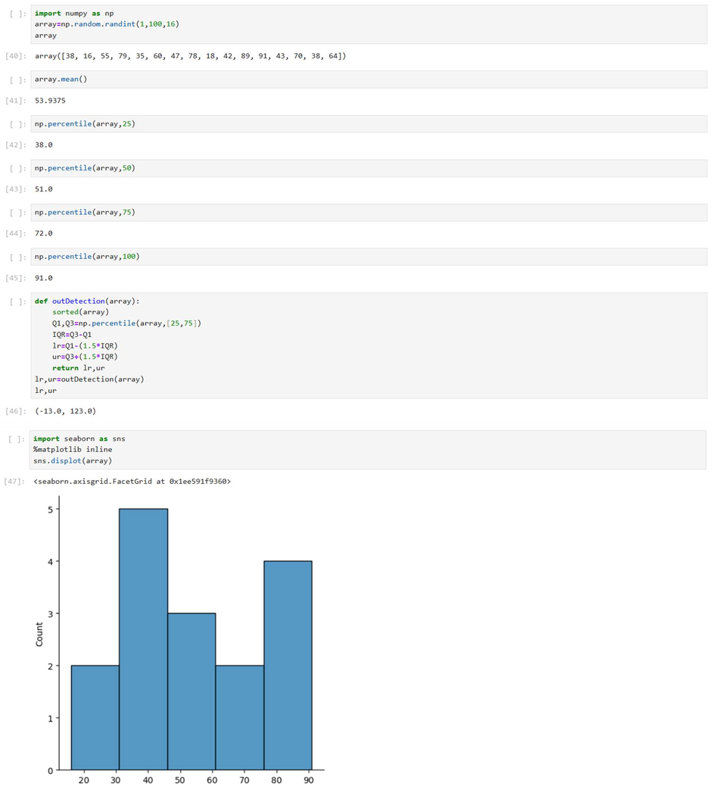

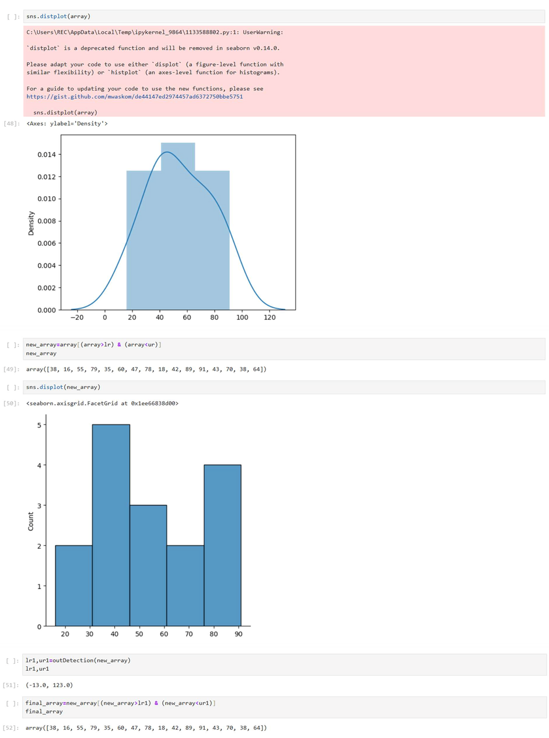
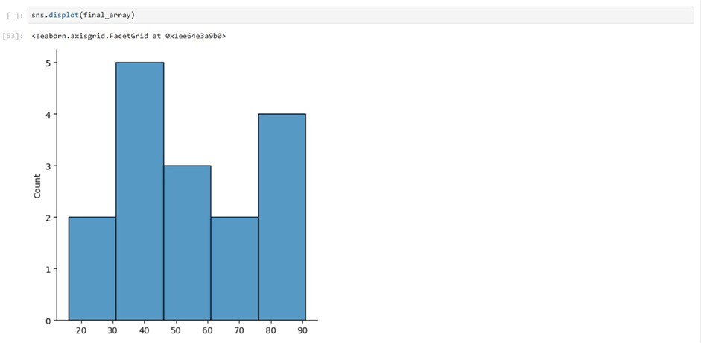

Exp:8. aExperiment to understand feature scaling.
Description: Understand the importance of feature scaling
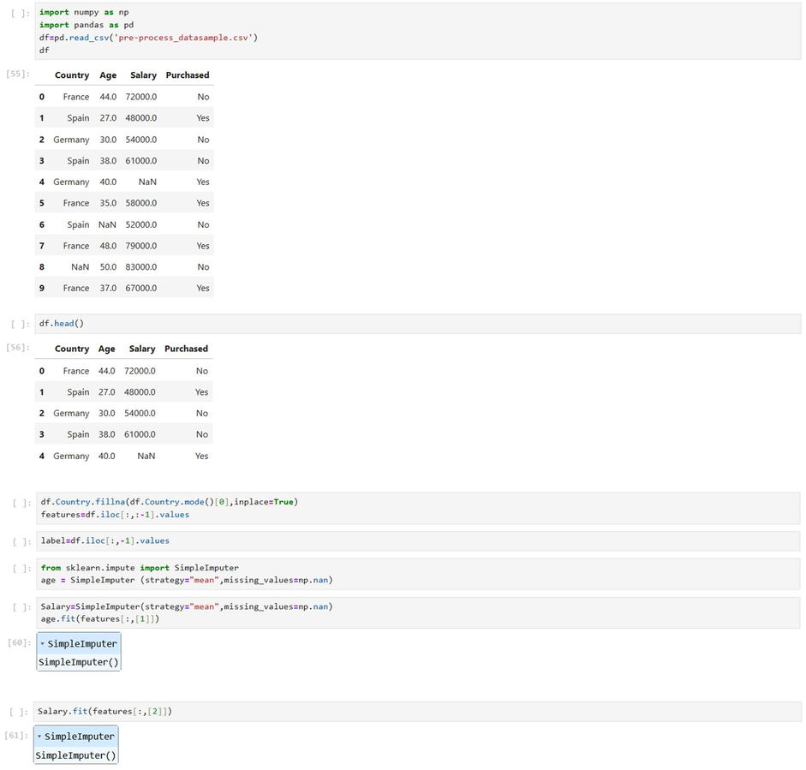

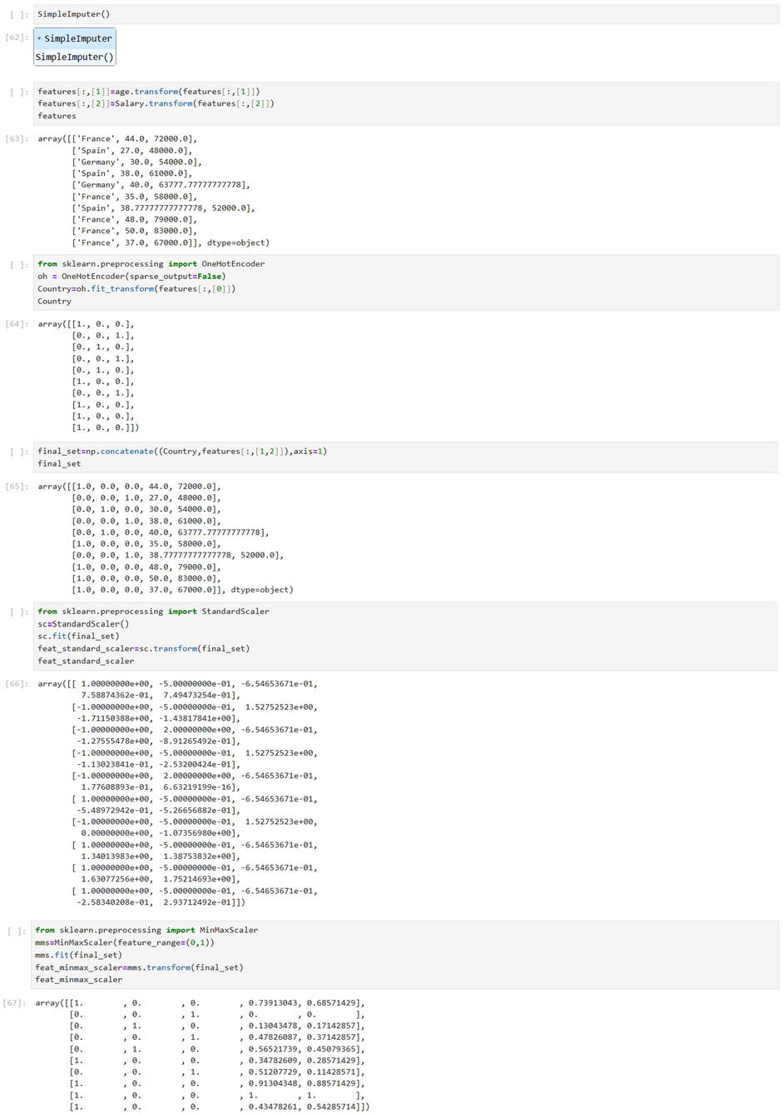

Exp:8. b Experiment to understand the data preprocessing in Data science
Description: Understand the importance of Data preprocessing in data science
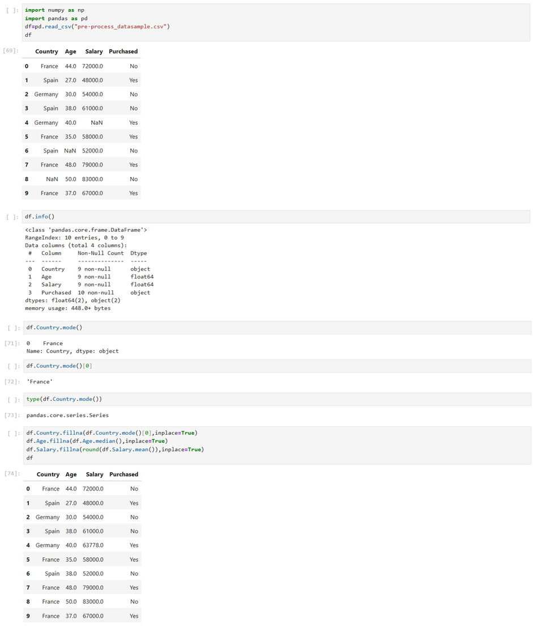

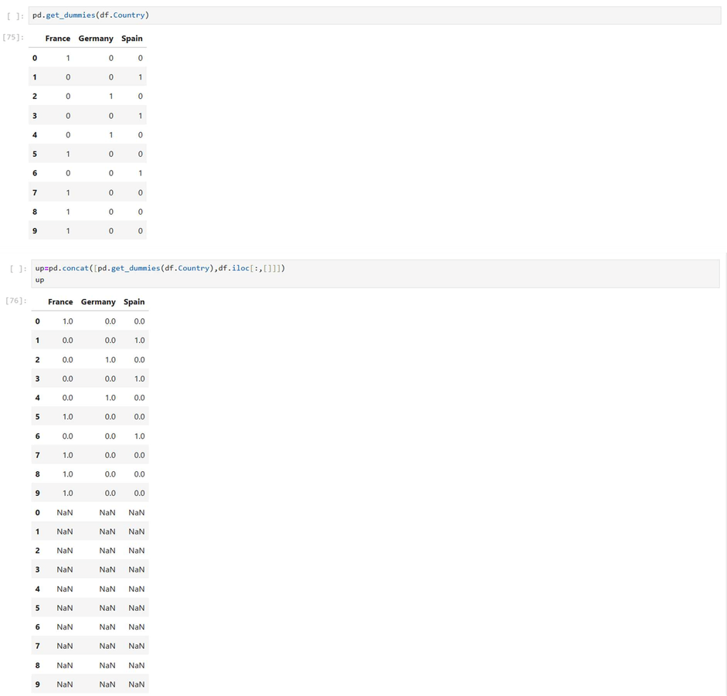

Exp No:9Experiment to understand EDA-Quantitative and Qualitative analysis.
Description: Understand the importance of EDA-Quantitative and Qualitative analysis.
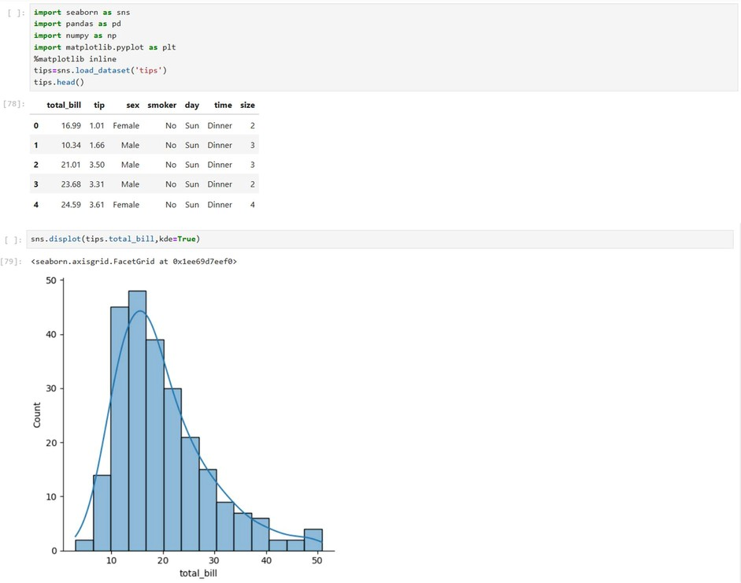

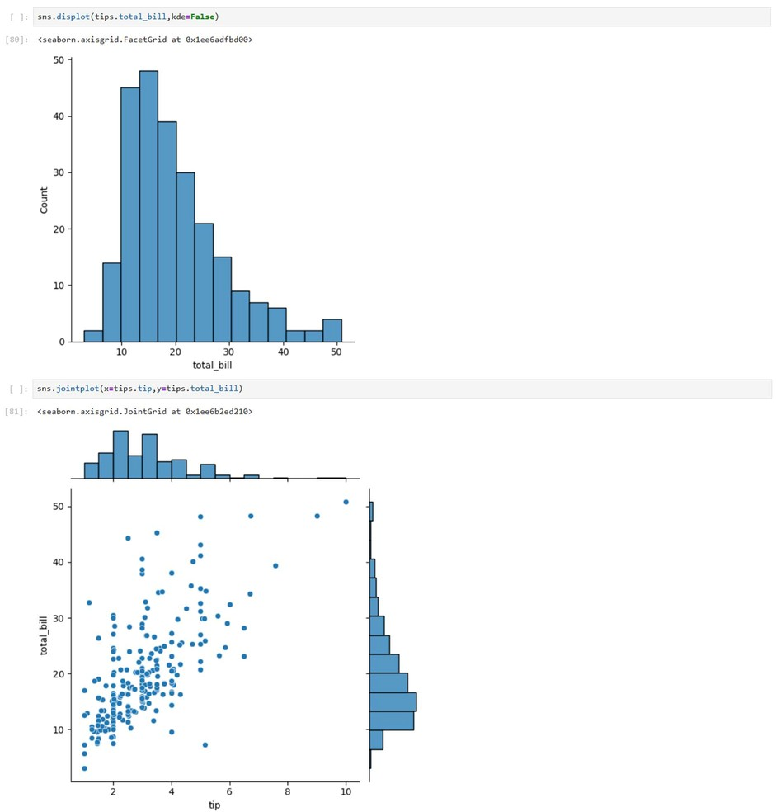
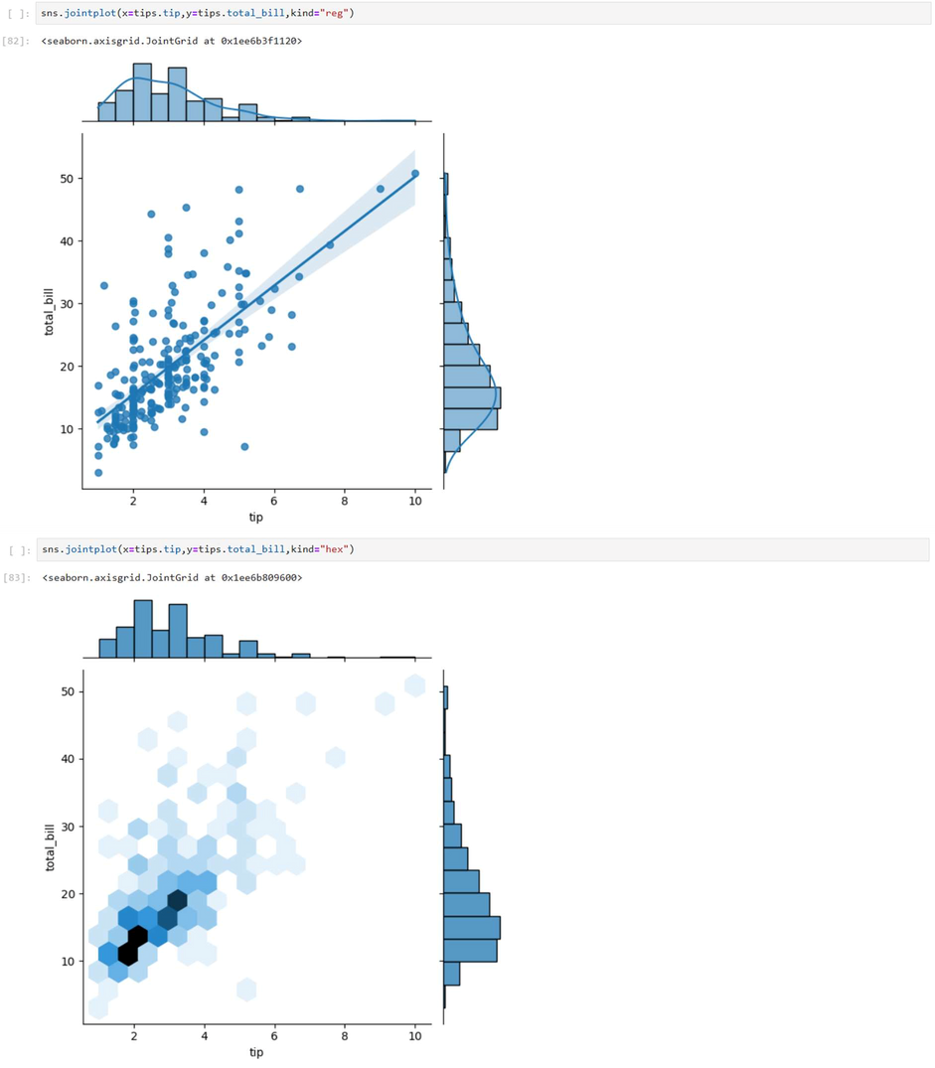
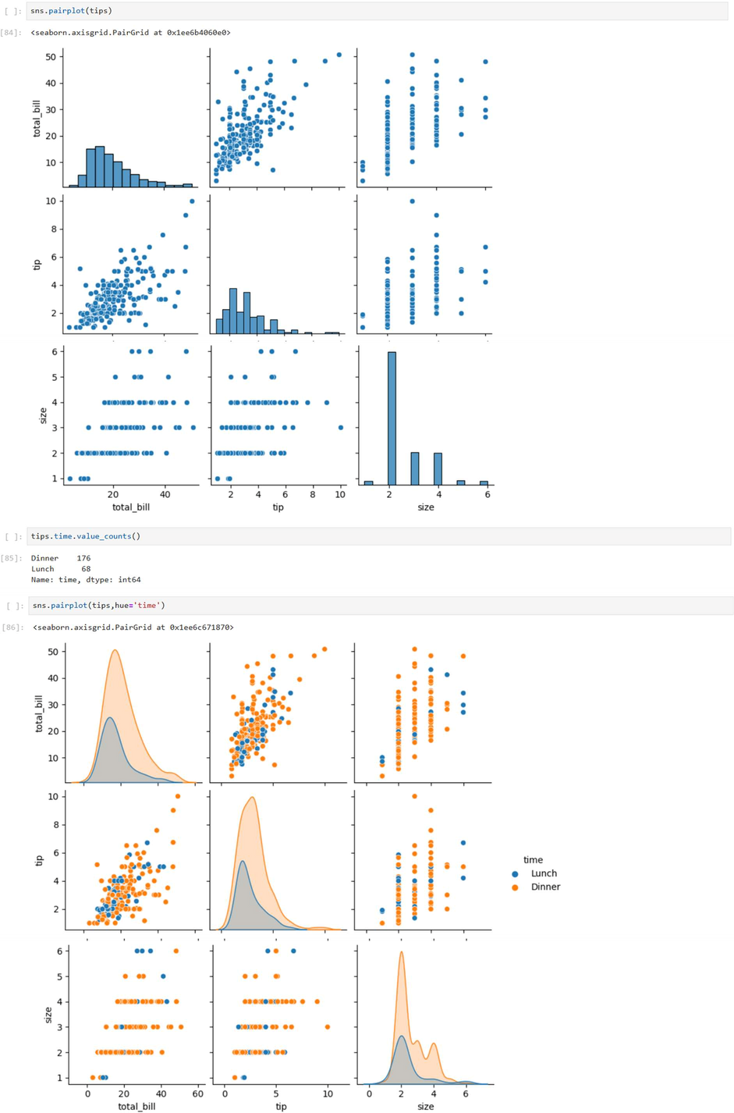
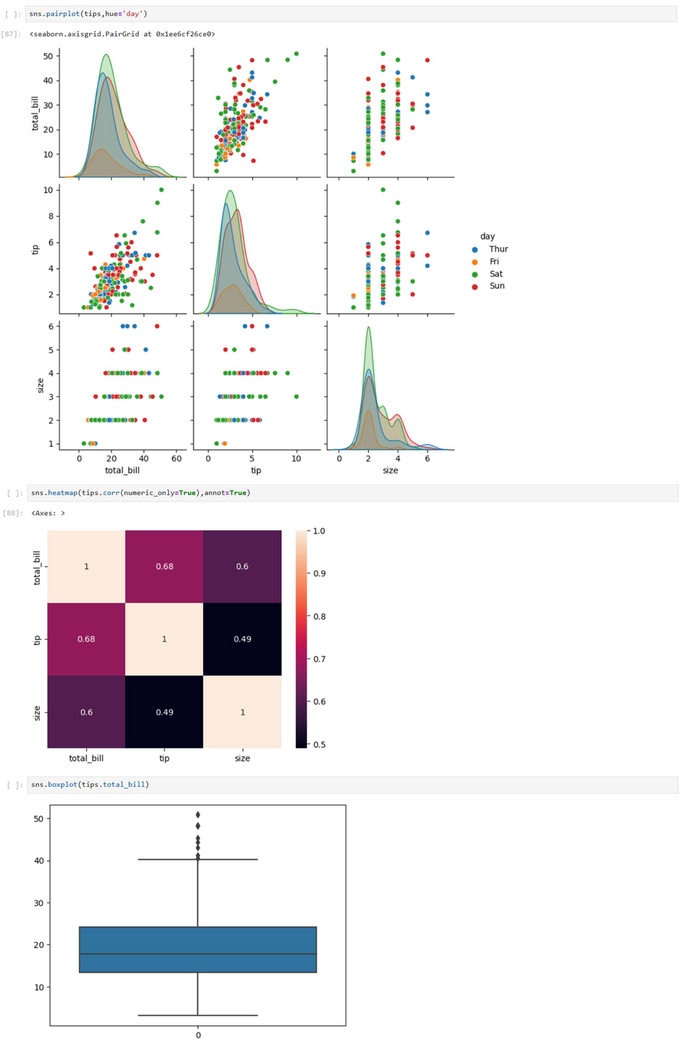
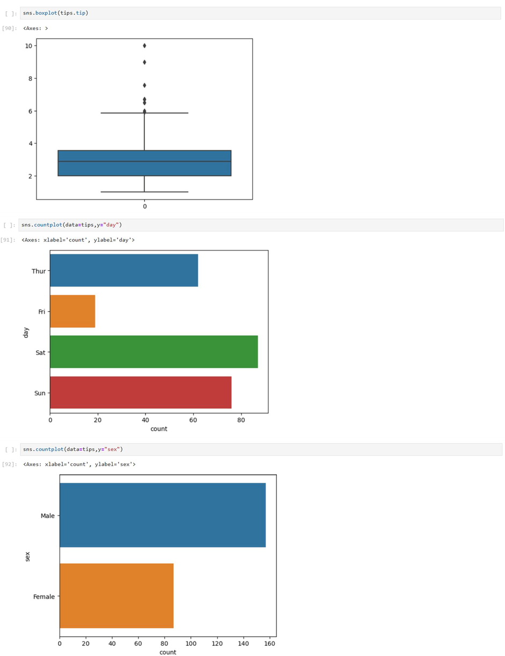
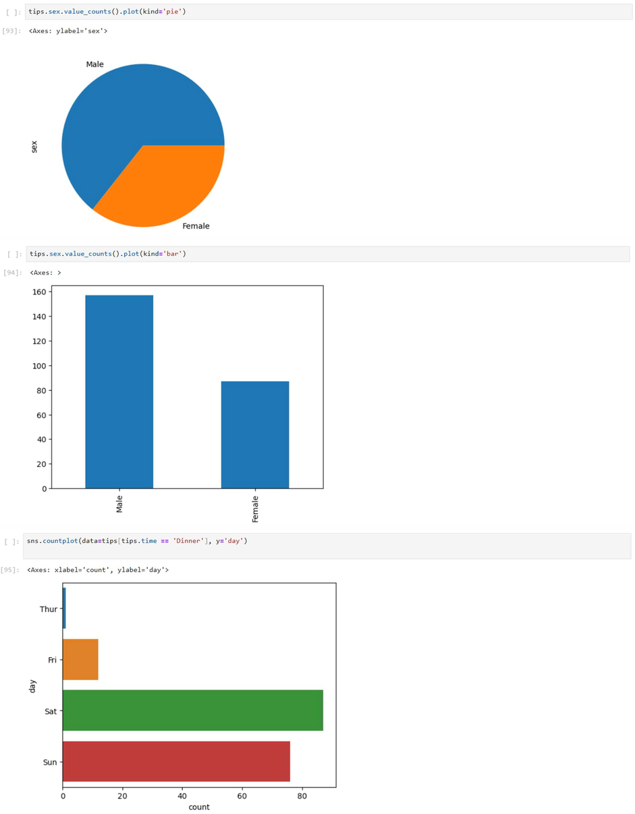

Exp:10 Regression
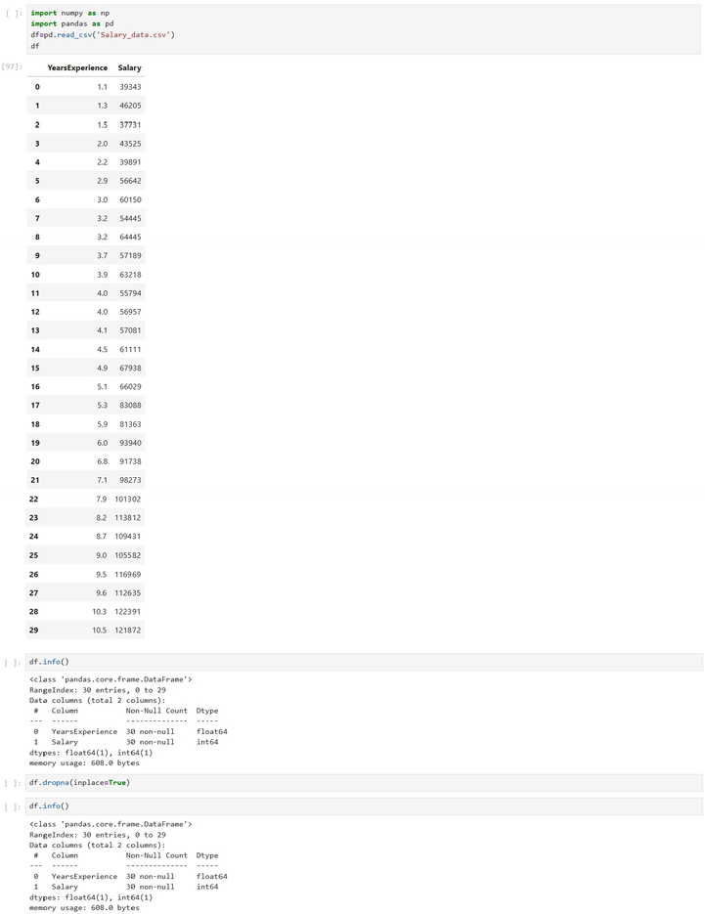

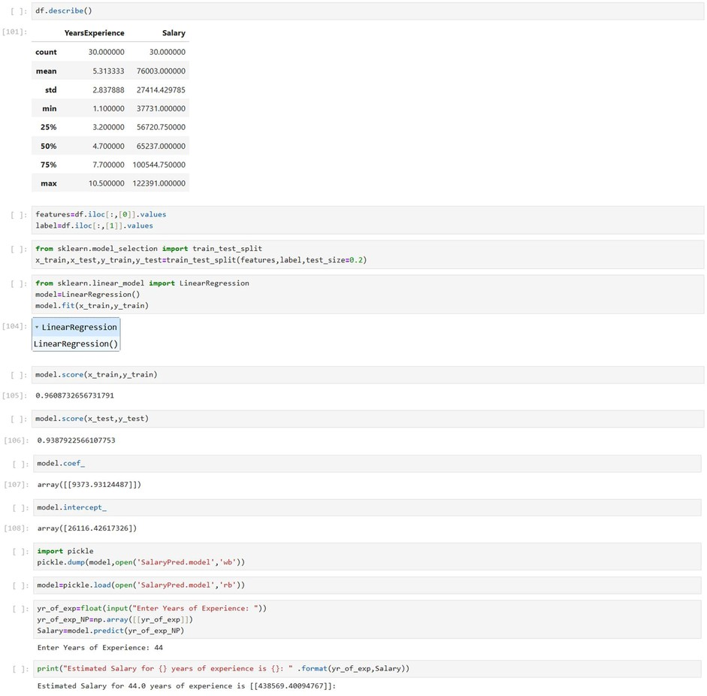

Exp:11 Logistic Regression
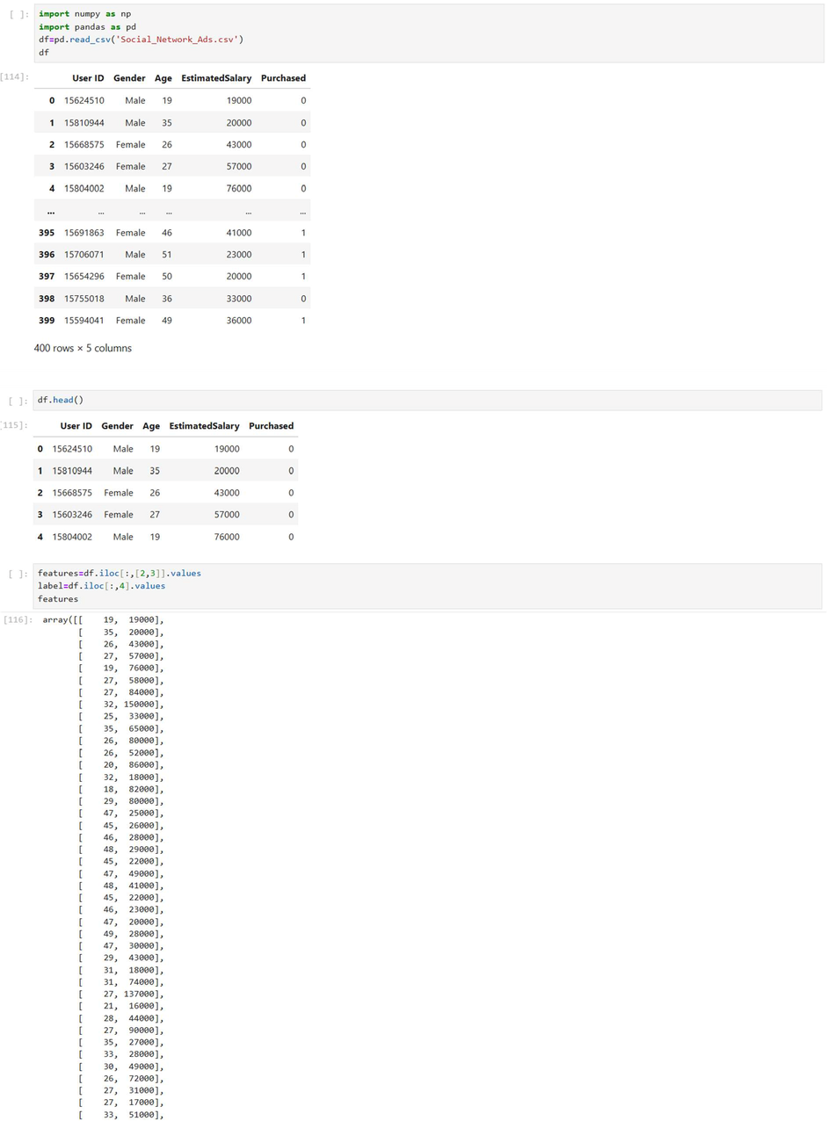

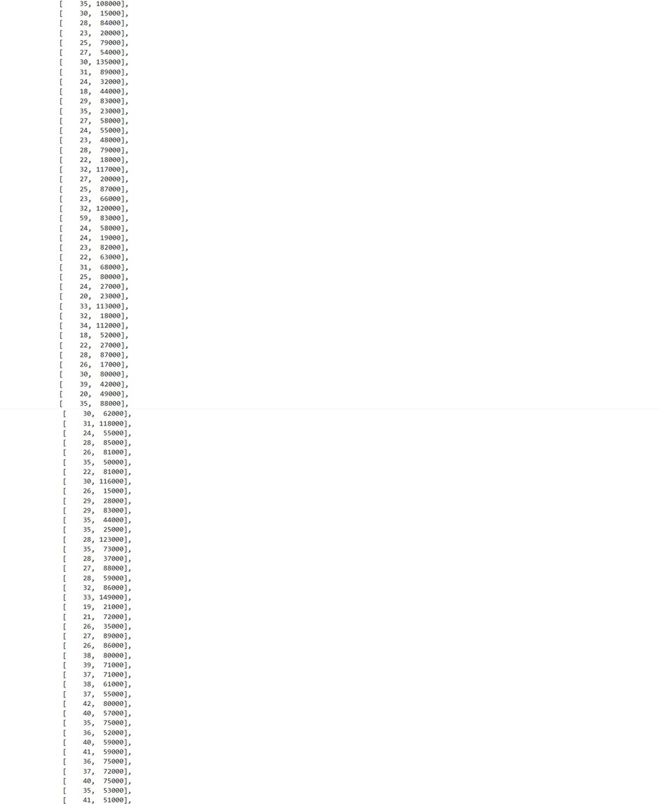
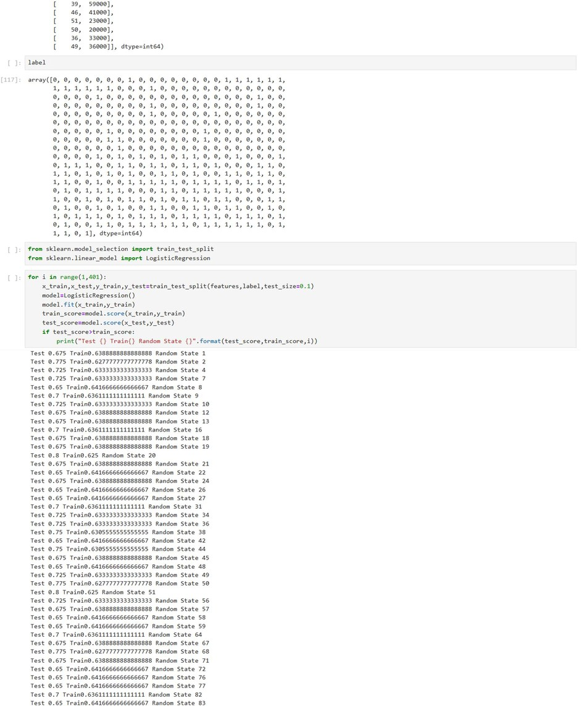
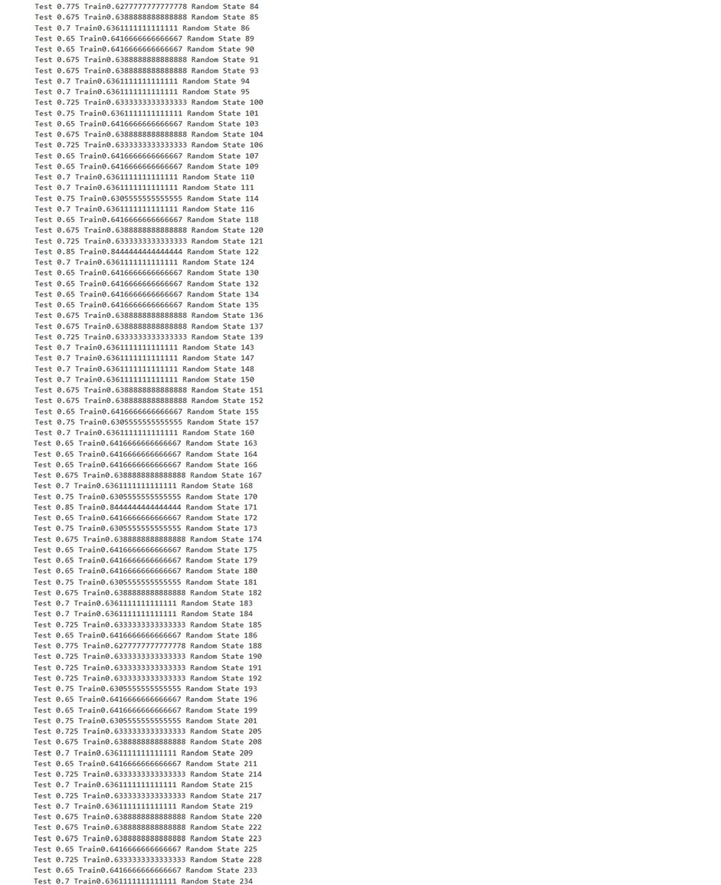
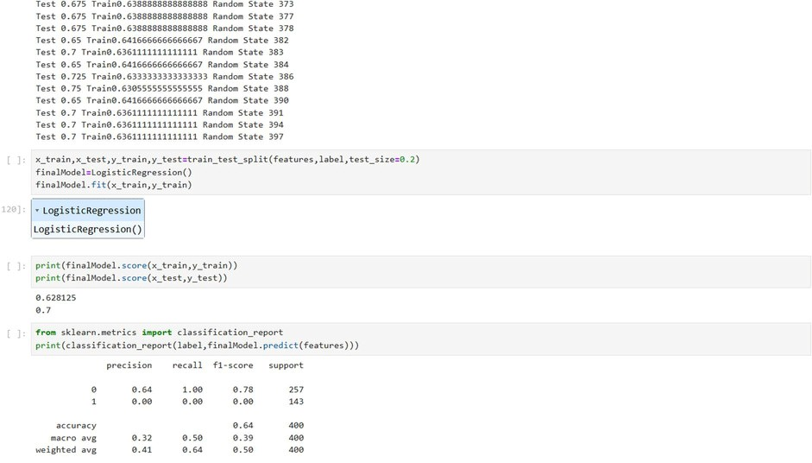

Exp:13. a KNN
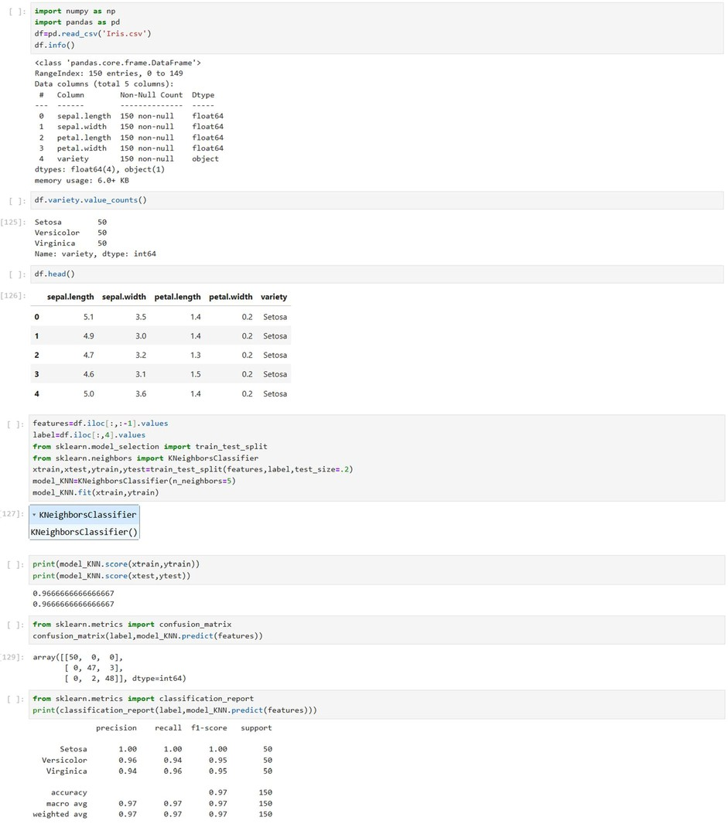
Exp:13. b K-Means
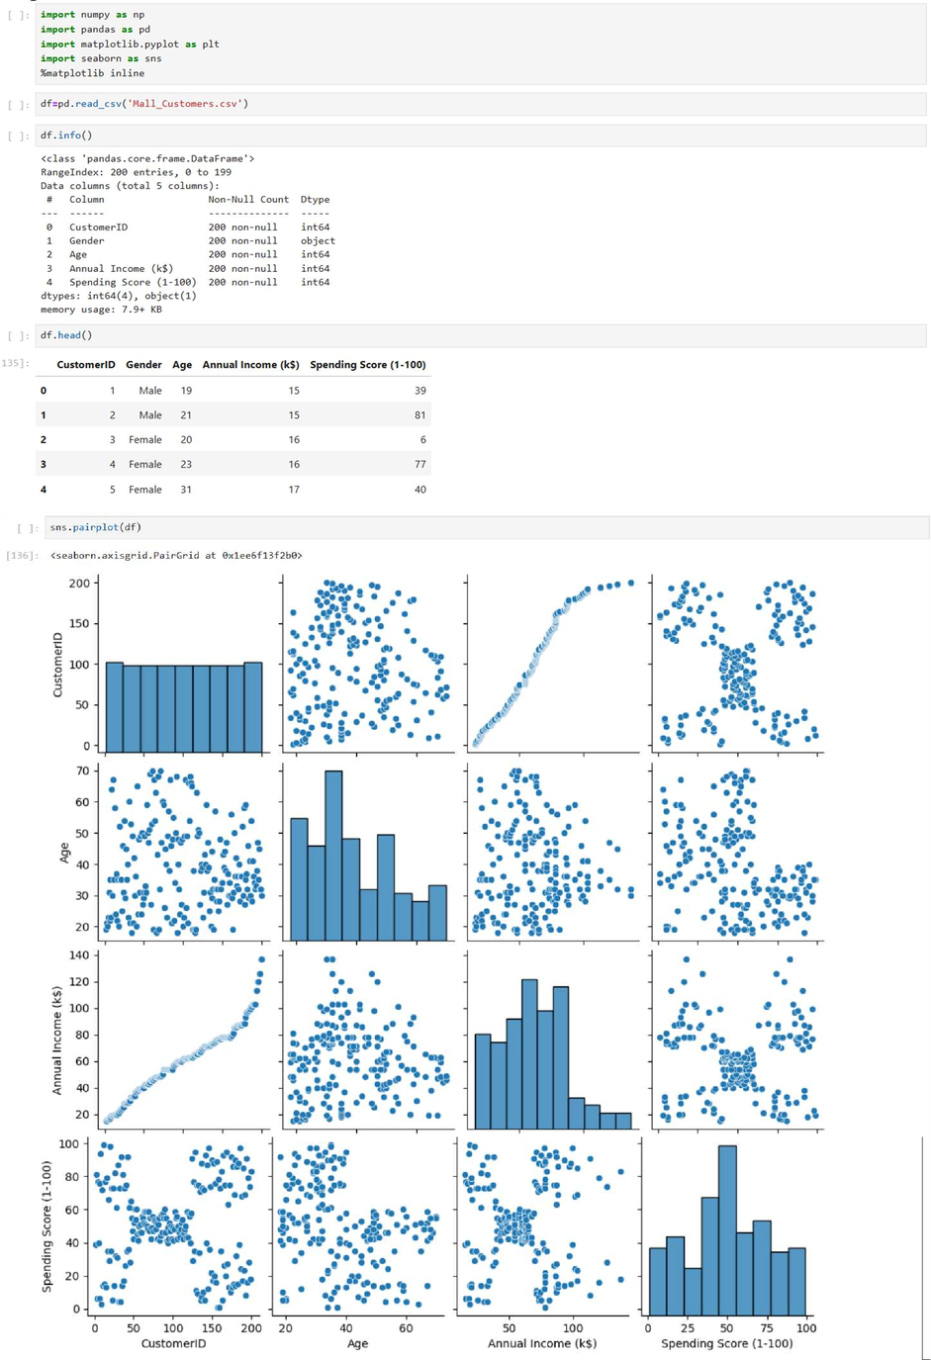

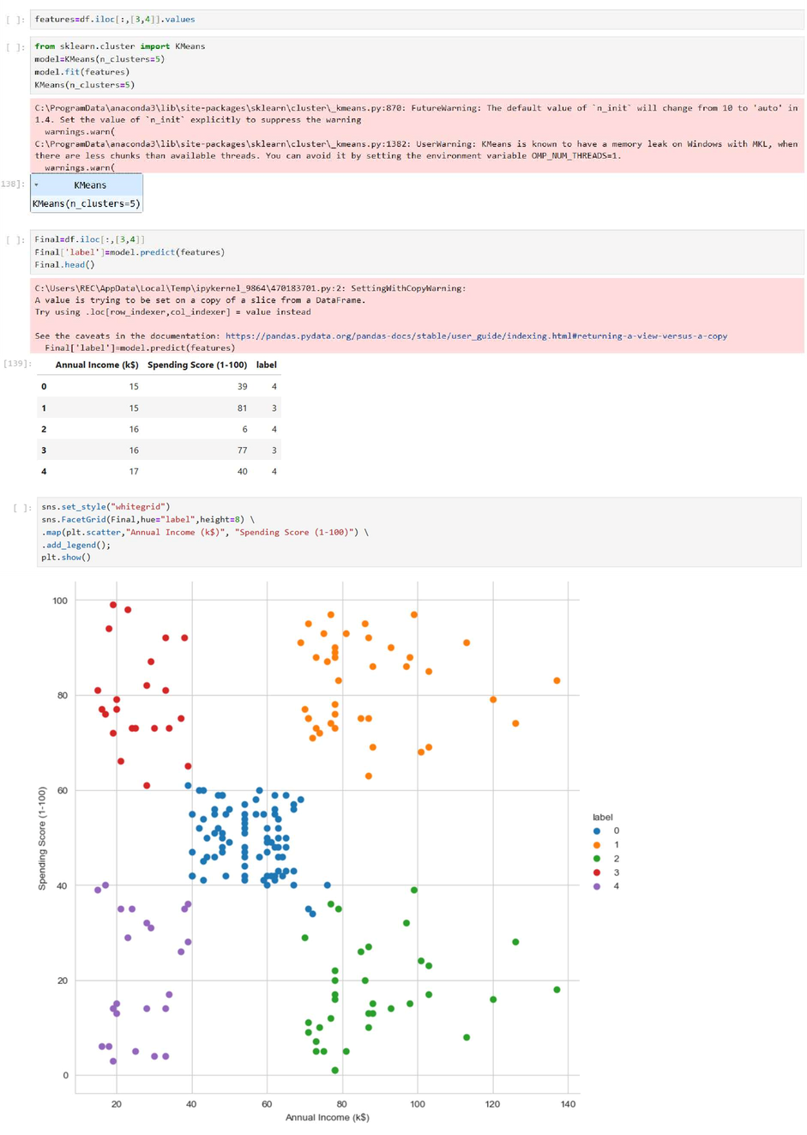
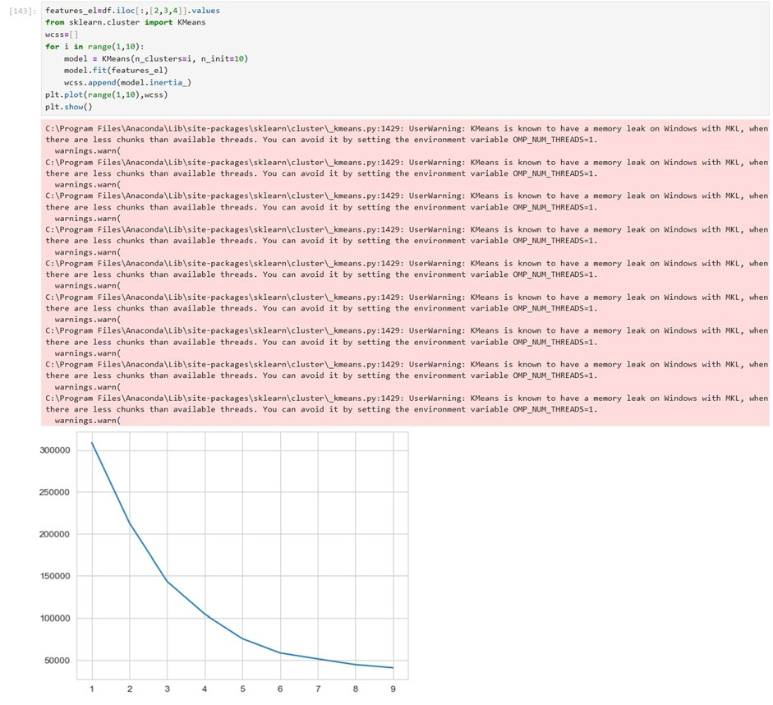

Exp:14 Testing
